AI-enabled pump monitoring solution

Customer Problem

Industrial pumps can fail because of overheating, vibration, blockage, cavitation, or wear.Operators often rely on threshold alarms or manual inspection.That means issues are detected late, causing downtime, maintenance cost, and risk to operations.

Customers need earlier detection of abnormal pump behavior so they can reduce unplanned downtime and move from reactive maintenance to predictive maintenance.

Business Value
Reduce unplanned downtime
Detect issues earlier than fixed thresholds
Improve maintenance prioritization
Reduce false confidence from single-sensor monitoring
Support transition to predictive maintenance
Create foundation for future remote monitoring services

Strong phrasing:

The value is not just anomaly detection accuracy. The real value is earlier intervention, better maintenance decisions, and reduced operational disruption.

System Architecture
Pump / sensor data source
↓
Data ingestion layer
↓
Feature engineering
↓
Anomaly detection engine
↓
Alerting Logic
↓
Streamlit monitoring dashboard
↓
Operator / maintenance action

Tech stack
Use a minimal stack:
Python
Pandas
NumPy
Scikit-learn or your own Gaussian calculation
Streamlit
Matplotlib / Plotly

That’s enough.

Data Pipeline

Sensor readings generated every minute
Raw signals: temperature, vibration, pressure, flow rate, power
Data cleaning / smoothing
Derived features created
Normal data used to fit Gaussian parameters
Cross-validation set used to tune threshold and improve features

AI logic
classic abnomaly detection logic

The model learns what normal pump behavior looks like
It estimates probability of new observations under normal conditions
If probability drops below a threshold, the system flags an anomaly
If some anomalies are missed, inspect them and add better features

Product Interface
Example dashboard:

Pump ID / location
Current health status: Normal / Warning / Critical
Sensor trend charts
Anomaly score
Recent alerts
Possible issue pattern
Recommended next step

Example:
“Pump P-102 shows abnormal vibration-to-flow ratio”
“Status: Warning”
“Suggested action: inspect impeller or check blockage”

Scope

v1

Inputs
Simulated pump sensor readings:

temperature
vibration
pressure
flow rate
power consumption

These are initial raw features.

Output
normal / anomaly
anomaly score
simple explanation or likely issue pattern

UI
A simple dashboard showing:

current sensor values
anomaly flag
time-series chart
recent alerts

Features

Inital raw featues
temperature
vibration
pressure
flow rate
power consumption

Engineered features
After the first run, likely add features like:

power / flow_rate
temperature_change_rate
vibration_change_rate
pressure_drop = expected_pressure - actual_pressure
flow_pressure_ratio
power * vibration
rolling mean / rolling std of vibration

Model
Gaussian anomaly detection

Anomaly scenarios

What “normal” and “anomaly” could mean

Normal
temperature stable
vibration low
pressure in normal range
flow rate stable
power roughly proportional to load

Anomalies
high vibration
high temperature
pressure drop
flow rate lower than expected
power unusually high for given flow

This is where feature engineering becomes important.You need a few realistic anomaly patterns in the simulated data.

Scenario A: Bearing wear
vibration gradually rises
temperature rises slightly
power rises

Scenario B: Cavitation
vibration spikes
flow becomes unstable
pressure fluctuates

Scenario C: Blockage

flow rate drops
pressure changes
power increases

Scenario D: Overheating

temperature rises abnormally
power stays high
vibration may stay normal

These will make your demo look much more realistic.

Out of Scope
- multiple pumps
- live streaming simulation
- fancy UI
- advanced explanation engine
- Docker deployment

Execution

Phase 1 — dataset simulation
Generate time-series pump data with normal and anomaly periods.

Goal: create a believable pump time-series dataset with normal periods and anomaly periods.

Deliverables: pump_sensor_data.csv

columns:

- timestamp
- pump_id
- temperature
- vibration
- pressure
- flow_rate
- power
- label
- anomaly_type

Where:
- label = 0 means normal
- label = 1 means anomaly
- anomaly_type is one of:
- normal
- bearing_wear
- cavitation
- blockage
- overheating

Steps

- Define one pump first. Do not start with multiple pumps.
- Generate normal data for, say, 2000–5000 time points.
- Data points
Use 5000 time points.
one reading per minute.
0–2999 → baseline / mostly normal
3000–4499 → monitoring period with anomaly windows
4500–4999 → return to normal
- define normal operating range
Temperature
center around 65°C
normal fluctuation: ±2°C

Vibration
center around 2.2 mm/s
normal fluctuation: ±0.3

Pressure
center around 5.0 bar
normal fluctuation: ±0.2

Flow rate
center around 100 L/min
normal fluctuation: ±4

Power
center around 12.0 kW
normal fluctuation: ±0.5

These numbers are not meant to be exact engineering truth.
They are just plausible operating values.

- create realistic normal relationships
Do not generate every column independently.That makes the data look fake.Use a few simple relationships:
Relationship ideas
  - Flow and power should be loosely related
Higher flow usually means slightly higher power.
Example logic: power ≈ 12 + 0.03 * (flow_rate - 100) + noise
  - Temperature should react a bit to power
Higher power tends to increase temperature slightly.
Example:temperature ≈ 65 + 0.4 * (power - 12) + noise
  - 3. Pressure and flow should have a mild relationship
Not too strong, just enough to avoid random independence.
Example logic: pressure ≈ 5.0 + 0.01 * (flow_rate - 100) + noise

- generate normal data

Start by generating all 5000 rows as normal.

Recommended approach
For each timestamp:

- generate base flow
- calculate power from flow
- calculate temperature from power
- calculate pressure from flow
- generate vibration independently with light noise
- label as normal

- Inject 4 anomaly scenarios:

- bearing wear
- cavitation
- blockage
- overheating

3150–3270 → bearing_wear
3500–3600 → cavitation
3870–3980 → blockage
4250–4360 → overheating

- Add light randomness so the data does not look too perfect.
- Save one clean dataset.

Time estimate

Fast version: 3 hours

If tuning realism: 4 hours

Advice

Do not over-engineer physics.
You are building a product case study dataset, not a mechanical engineering simulator.

Finished 2026 Mar 8 9:25 PM

Phase 2 — baseline anomaly detector
Train on mostly normal data and compute anomaly scores.

Goal: build the first working Gaussian anomaly detection pipeline.

Deliverables

- notebook or script:

- split train / CV / test
- fit Gaussian parameters on normal data
- compute anomaly score
- choose epsilon from CV set
- evaluate precision / recall / F1

Steps

- Use only raw features first:

- temperature
- vibration
- pressure
- flow_rate
- power

- Split the data

For this project, a clean split is:

- Train: use mostly normal baseline rows
- CV: use a mix of normal + anomaly rows
- Test: use later unseen rows

Because your dataset is time-ordered, we should keep the split chronological, not random. A practical version:

- Train: rows 0–2999
- CV: rows 3000–3999
- Test: rows 4000–4999

- Train only on normal samples.
For each feature, estimate:
- mean mu
- variance sigma^2

This defines the normal model.

Here is a result of a run.
Features:
['temperature', 'vibration', 'pressure', 'flow_rate', 'power']

Mean (mu):
temperature: 64.991467
vibration: 2.198154
pressure: 5.003118
flow_rate: 100.185425
power: 12.001851

Variance (var):
temperature: 0.413293
vibration: 0.010124
pressure: 0.005795
flow_rate: 7.835715
power: 0.048461

- Compute probability score for each example

For each row, compute:
probability under the normal model
Low probability means more anomalous.

- Use CV set with anomalies included to tune threshold epsilon.
Use the CV set:
try many candidate epsilon values
choose the one with the best F1 score

- Evaluate on Test set. Print:

- confusion matrix
- precision = when I alert, how often am I right?
- recall = of all real anomalies, how many did I catch?
- F1 = balance of the two

- False positive = false alarm
- False negative = missed anomaly

And your model currently is:

- reasonably good at catching anomalies
- not yet good enough at avoiding false alarms
- good enough to justify feature engineering

- Error analysis. Look at:

- which anomaly windows were detected well
- which were missed
- whether some anomaly types are harder than others

Time estimate

2 to 3 hours

Advice

Your first model is supposed to be imperfect.
That is actually good, because it gives you a reason to explain feature engineering.

Phase 2 results:

Summary:
- the baseline detector works on raw features
- bearing wear and overheating are easier to detect
- cavitation and blockage need better features

Key metrics:

Selected epsilon from CV: 1.895084575972e-02
Best CV F1: 0.7333

=== CV Metrics ===
Precision: 0.8240
Recall: 0.6607
F1: 0.7333
Confusion Matrix:
[[620 47]
[113 220]]

=== Test Metrics ===
Precision: 0.5891
Recall: 0.6847
F1: 0.6333
Confusion Matrix:
[[836 53]
[ 35 76]]

=== Performance by Anomaly Type (Test Set) ===

Normal rows:
Total normal points: 889
Correctly normal: 836
False alarms (FP): 53
False alarm rate: 0.0596

Anomaly Type: overheating
Total points: 111
Detected points: 76
Missed points: 35
Detection rate: 0.6847
Avg anomaly score: 1.340483e-01
Min anomaly score: 1.214337e-11
Max anomaly score: 1.557202e+00

=== Performance by Anomaly Type (Full Monitoring Region: rows 3000–4999) ===

Normal rows:
Total normal points: 1556
Correctly normal: 1456
False alarms (FP): 100
False alarm rate: 0.0643

Anomaly Type: bearing_wear
Total points: 121
Detected points: 96
Missed points: 25
Detection rate: 0.7934
Avg anomaly score: 6.799062e-02
Min anomaly score: 4.723364e-23
Max anomaly score: 1.618197e+00

Anomaly Type: cavitation
Total points: 101
Detected points: 57
Missed points: 44
Detection rate: 0.5644
Avg anomaly score: 1.454140e-01
Min anomaly score: 1.203570e-07
Max anomaly score: 2.446971e+00

Anomaly Type: blockage
Total points: 111
Detected points: 67
Missed points: 44
Detection rate: 0.6036
Avg anomaly score: 1.277739e-01
Min anomaly score: 6.512604e-08
Max anomaly score: 2.116424e+00

Anomaly Type: overheating
Total points: 111
Detected points: 76
Missed points: 35
Detection rate: 0.6847
Avg anomaly score: 1.340483e-01
Min anomaly score: 1.214337e-11
Max anomaly score: 1.557202e+00Third, freeze the current version before changing anything:

Main conclusion

This is the key interpretation: The raw-feature Gaussian model detects clear value-shift anomalies better than instability-driven anomalies.

bearing wear and overheating are easier
cavitation is hardest
blockage is also not captured strongly enough

That is exactly the type of insight you want before feature engineering.

Why cavitation is the hardest

Because cavitation is not just:“one value becomes very high”
It is more like:
unstable fluctuation
oscillation
noisy local behavior

Your current model only sees each row independently.
So if a single row still looks numerically plausible, it may not flag it.

That is why cavitation is the perfect reason to add time-related or relationship-based features later.

Why blockage is only medium

Because blockage is more about a relationship:
lower flow
somewhat higher power
maybe slight temperature rise
A single raw row may not always look extreme enough on any one variable alone.

So the model misses some blockage points because it does not yet explicitly know things like:

power relative to flow
pressure relative to flow

Best feature-engineering priorities

Based on your result, the next features should target:

1. Cavitation

Best candidate:
vibration_rolling_std
maybe flow_rate_change
maybe pressure_change

2. Blockage

Best candidate:
power_flow_ratio
maybe flow_pressure_ratio

Those are the two weakest anomaly types, so that’s where feature engineering should focus.

What I would do next? For Phase 3, start with just three engineered features:

power_flow_ratio = power / flow_rate
flow_pressure_ratio = flow_rate / pressure
vibration_rolling_std

Why these three:

power_flow_ratio helps blockage
flow_pressure_ratio helps blockage / system imbalance
vibration_rolling_std helps cavitation

That is a focused and meaningful next step.

Phase 3 — feature engineering
Inspect missed anomalies and add derived features.
Goal: improve detection using Andrew’s workflow: inspect misses, then add better features.

Deliverables

- updated feature list
- improved model results
- short note on why each engineered feature was added

Suggested engineered features

Start with only 3–5, not all at once:
- power_flow_ratio = power / flow_rate
- temp_change_rate
- vibration_change_rate
- flow_pressure_ratio = flow_rate / pressure
- rolling std of vibration

Steps

- Review missed anomalies from Phase 2.
- Ask: what pattern makes them abnormal but hidden?
- Add one feature at a time.
- Re-run training and CV evaluation.
- Keep only the features that help.

Time estimate

2 to 3 hours

Advice

This phase is very important for interview storytelling.
You want to be able to say:

“The initial model missed some cavitation and blockage cases, so I added ratio and rate-based features to better represent abnormal operating relationships.”

That sounds strong.

Phase 3 — Feature Engineering Iteration Summary

Objective

The goal of Phase 3 was to improve the baseline Gaussian anomaly detector from Phase 2 through feature engineering, especially for the weaker anomaly types identified earlier:

- cavitation
- blockage

Phase 2 showed that the raw-feature Gaussian model was a useful baseline, but it did not detect all anomaly types equally well. In particular, cavitation and blockage were harder to detect than bearing wear and overheating.

Phase 3 design idea
Following Andrew Ng’s anomaly detection workflow, the approach in Phase 3 was:

- review Phase 2 detection results
- identify weak anomaly patterns
- hypothesize what kinds of features might better represent those patterns
- add a small number of engineered features
- retrain and reevaluate
- compare against the Phase 2 baseline

The intention was not to jump to a complicated model, but to test whether better features alone could improve a simple Gaussian anomaly detector.

Experiment 1 — ratio features + rolling volatility feature
Features added

- power_flow_ratio
- flow_pressure_ratio
- vibration_rolling_std

Why these were chosen

- power_flow_ratio was intended to help detect blockage, where power may increase while flow drops
- flow_pressure_ratio was intended to help capture abnormal cross-signal relationships
- vibration_rolling_std was intended to help detect cavitation, since cavitation is more about unstable fluctuation than absolute value shift

Result

This version did not improve the model overall.

Main observations:

blockage detection improved significantly
however, false alarm rate increased
precision dropped
cavitation detection did not improve
overall model stability became worse than the Phase 2 baseline

Interpretation

This experiment showed that:

relationship-based ratio features can be useful for blockage, but the short-window rolling standard deviation introduced too much noise. normal rows were penalized too easily. the detector became less stable overall

Experiment 2 — ratio features only
Features kept

- power_flow_ratio
- flow_pressure_ratio

Feature removed

- vibration_rolling_std

Why this version was tested

The rolling volatility feature appeared to be the main reason for increased noise and false alarms, so it was removed to isolate the effect of the ratio features.

Result

This version was better than Experiment 1, but still not better than the Phase 2 baseline.

Main observations:

blockage detection remained strong
false alarm rate improved relative to Experiment 1
but cavitation detection became worse than the baseline
overall test F1 was still below Phase 2

Interpretation

This experiment confirmed that: ratio features are helpful for blockage-like anomalies, but they do not solve the cavitation problem, and they still did not produce a better overall detector than the raw-feature baseline

Experiment 3 — raw features + temporal difference feature
Features used

- original raw sensor features
- flow_rate_diff

Why this version was tested

The earlier experiments suggested that cavitation likely requires a more temporal representation. Instead of using rolling volatility, a simpler temporal feature was tested:

difference between the current flow rate and the previous point

This was intended to capture short-term instability without introducing as much noise as rolling standard deviation.

Result

This version was the best engineered-feature attempt, but it still did not outperform Phase 2 overall.

Main observations:

false alarm rate stayed close to the Phase 2 baseline
bearing wear detection stayed strong
overheating stayed reasonably strong
cavitation did not improve meaningfully
blockage became slightly worse than the Phase 2 baseline
overall test F1 remained slightly below Phase 2

Interpretation

This experiment showed that: a lightweight temporal-difference feature is safer than a noisy rolling-volatility feature. but one simple difference feature is still not enough to materially improve the detector. cavitation likely requires better temporal representation than what was used here

Overall conclusion of Phase 3
What worked

- feature engineering produced useful diagnostic insight
- ratio features clearly helped blockage
- rolling short-window volatility was too noisy
- simple temporal difference was more stable than rolling volatility

What did not work

- none of the engineered-feature versions clearly outperformed the Phase 2 raw-feature baseline
- cavitation remained difficult to detect
- the model is still only a baseline detector from an engineering perspective

Best model after Phase 3

The strongest overall v1 detector remains: Phase 2 raw-feature Gaussian model

Reason:

best overall balance of precision, recall, F1, and false alarm rate
strongest general stability across anomaly types

Product and case-study takeaway
Although Phase 3 did not produce a stronger final model, it was still highly valuable from a product and design perspective because it demonstrated a realistic iteration process:

identify weak performance areas
form hypotheses about failure patterns
test multiple feature strategies
compare tradeoffs
decide which version is strongest for v1

This is useful for the case study because it shows not just implementation, but structured problem solving, model interpretation, and design iteration.

Future technical backlog
Phase 3 also clarified possible future improvement directions:
- larger-window temporal features
- difference features on other sensors such as pressure or vibration
- feature transformation to make some variables more Gaussian
- multivariate Gaussian modeling instead of independent-feature product
- more advanced anomaly detection methods in later versions

Final Phase 3 statement
Phase 3 tested several feature-engineering strategies to improve the Gaussian anomaly detector beyond the raw-feature baseline. Ratio-based features improved blockage detection, but increased model tradeoffs and did not improve overall performance. A simpler temporal-difference feature preserved stability better, but still did not outperform the baseline. As a result, the raw-feature Gaussian detector remained the strongest v1 model, while the Phase 3 experiments provided useful insight into which anomaly types require relationship-based versus temporal features.

Phase 4 — dashboard
Show sensor trends and alerts.

Goal: turn the model into a product demo.

Deliverables

A Streamlit app with:

- current pump status
- sensor trend charts
- anomaly score
- anomaly flag
- recent alerts
- possible issue pattern / recommended action

Minimum UI

- Header:

- Pump Health Monitoring Dashboard

- Top KPIs:

- Pump ID
- Current status
- Latest anomaly score

- Charts:

- temperature over time
- vibration over time
- pressure / flow / power over time

- Alert table:

- timestamp
- anomaly score
- likely issue

- A simple rule-based explanation:

- high vibration + slight temp rise → bearing wear
- unstable vibration + pressure fluctuation → cavitation
- low flow + higher power → blockage
- high temp only → overheating

Time estimate

4 to 5 hours

Advice

Do not try to build a beautiful enterprise UI in v1.
Build a clear UI.

Phase 4 — Product Definition Note

Purpose of Phase 4
The purpose of Phase 4 is to shift the project from a pure anomaly-detection experiment into a usable product concept.

At this stage, the goal is not to build a full industrial platform, but to define a clear product flow around the existing pump anomaly detection prototype. The intention is to practice product thinking by translating the technical model into a dashboard and workflow that supports real user decisions.

This phase focuses on:

- who the user is
- what problem the user is trying to solve
- what questions the product must answer
- what scenarios the product must support
- what information and screen sections are needed in the first version

The current scope is intentionally simplified:

- one pump
- one dashboard
- one primary operational flow

This is not meant to represent the full complexity of a real industrial deployment, but rather a focused v1 product case that demonstrates the design process clearly.

Primary users
1. Plant operator

The plant operator is responsible for monitoring day-to-day pump operation and quickly identifying whether the equipment is running normally.

The operator’s core need is not deep diagnosis, but fast situational awareness:

- is the pump healthy right now?
- is there an abnormal condition?
- do I need to keep monitoring or escalate?

The operator typically needs:

- a quick status view
- clear severity indication
- simple guidance on whether action is needed

2. Maintenance engineer

The maintenance engineer is responsible for investigating abnormal behavior and determining what should be inspected or addressed next.

The maintenance engineer’s core need is interpretability:

- what changed?
- what pattern does the abnormality resemble?
- what should I check first?

The maintenance engineer typically needs:

- trend visibility
- signal comparison
- likely issue hints
- a basis for deciding next steps

Product objective
The product objective of this v1 dashboard is:

to help operators and maintenance engineers detect abnormal pump behavior earlier, understand what changed, and decide what action to take next.

This means the product should not only indicate that an anomaly exists, but also provide enough context to support decision-making.

Core product questions
The product should be designed to answer the following four questions.

- Is the pump healthy right now?

This is the first and most important question.
The product must allow the user to quickly determine whether the pump is in a normal state, warning state, or abnormal state.

- If not, what changed?

If the system detects abnormal behavior, the user must be able to understand which operating signals changed and how the current condition differs from normal behavior.

- What is the likely issue pattern?

The anomaly detector itself only identifies abnormal behavior. The product should add a lightweight interpretation layer that gives the user a practical issue hint, such as:

- overheating
- bearing wear
- cavitation
- blockage
- unknown anomaly

This does not need to be a perfect fault-classification engine, but it should help users interpret what the anomaly may represent.

- What should I do next?

The product should help the user move from awareness to action.
Depending on the situation, the next step may be:

- continue monitoring
- inspect the pump
- escalate to maintenance
- check blockage conditions
- review vibration or temperature behavior

Without this layer, the product would be only a visualization tool, not a useful operational product.

Scenarios

Scenario 1 — routine monitoring
User: plant operator
Situation: the operator opens the dashboard during normal operation
Goal: confirm that the pump is healthy and no intervention is needed

User expectation

The operator wants to know within a few seconds:
- whether the pump is normal
- whether any anomaly has recently been detected
- whether continued monitoring is sufficient

Product response

The dashboard should provide:
- current health status
- latest anomaly score
- recent alert summary
- high-level confidence that the pump is behaving normally

This scenario emphasizes speed and clarity.

Scenario 2 — abnormal alert appears
User: plant operator
Situation: the dashboard shows a warning or anomaly state
Goal: determine whether the issue requires immediate escalation or continued observation

User expectation
The operator wants to know:
- how serious the abnormality is
- when it began
- which signals look different
- whether this appears to be a transient fluctuation or a more persistent issue

Product response

The dashboard should provide:
- clear alert status
- visual trend change
- likely issue hint
- basic recommended action

This scenario bridges detection and operational response.

Scenario 3 — maintenance investigation
User: maintenance engineer
Situation: an abnormal period has been flagged and requires review
Goal: understand the pattern of the abnormality and decide where to inspect first

User expectation

The maintenance engineer wants to know:
- which signals deviated most clearly
- whether the anomaly pattern resembles overheating, cavitation, blockage, or bearing wear
- whether the abnormality is sustained, increasing, or stabilizing

Product response

The dashboard should provide:
- detailed sensor trend charts
- anomaly markers on the timeline
- a likely issue pattern
- recent alert history
- suggested inspection direction

This scenario emphasizes interpretability rather than only detection.

Scenario 4 — post-event review
User: maintenance engineer or supervisor
Situation: an abnormal period has passed or the pump has returned to normal
Goal: review what happened and determine whether the issue was temporary, resolved, or requires follow-up

User expectation

The user wants to know:
- when the anomaly started
- how long it lasted
- which signals changed
- whether the pump returned to stable normal operation afterward

Product response

The dashboard should provide:
- timeline history
- anomaly duration visibility
- return-to-normal behavior
- alert history summary

This scenario supports operational learning and follow-up decisions.

Product design principles for v1
This first product version should follow a few simple principles:

- Fast first glance

The user should be able to understand current health status immediately.

- Clear transition from status to diagnosis

The product should guide the user from:

- “something is wrong” to
- “what changed” to
- “what should I do next”

- Support action, not only visualization

The dashboard should help the user decide what to do, not just display charts.

- Keep v1 simple

The first version should focus on a narrow but coherent use case:

- one pump
- one page
- one operator / maintenance flow

Core screen sections for v1
- Summary status panel

This section supports the question:
Is the pump healthy right now?

It should contain:

- Pump ID
- current health status
- latest anomaly score
- current alert state
- likely issue pattern

This section is the at-a-glance overview.

- Sensor trend section

This section supports the question:
If not, what changed?

It should contain:

- temperature trend
- vibration trend
- pressure trend
- flow rate trend
- power trend
anomaly markers or highlighted periods

This section helps the user visually understand signal behavior over time.

- Issue interpretation and recommended action section

This section supports the questions:
What is the likely issue pattern?
What should I do next?

It should contain:

- likely issue pattern
- brief reasoning or rule-based explanation
- recommended next step

This section transforms anomaly detection into a usable product response.

- Recent alerts / event table

This section supports both investigation and review.

It should contain:

- recent timestamped alerts
- anomaly score
- predicted anomaly label
- issue hint

recommended action

This section provides traceability and operational context.

In scope for v1
The first product version will include:

- one dashboard page
- one pump
- current status summary
- sensor trend charts
- anomaly detection result display
- likely issue pattern using lightweight rule-based logic
- recent alert history table

This scope is sufficient for a first case-study product demo.

Out of scope for v1

The following items are intentionally excluded from the first version:

- multiple pumps
- fleet-level comparison
- user roles and permissions
- live data streaming
- real database integration
- maintenance work-order system integration
- advanced root-cause classification model
- alert acknowledgement workflow
- mobile optimization
- enterprise-grade visual polish

These are all reasonable future directions, but they are not needed for the current practice and case-study objective.

Expected outcome of Phase 4
By the end of Phase 4, the project should no longer feel like only a machine learning prototype. It should feel like the first version of an AI-enabled pump monitoring product, with a user-centered interface and a clear operational purpose.

The intended outcome is:

- a clearer product story
- a more interview-ready case study
- a more convincing portfolio artifact
- better practice in product design thinking for industrial AI use cases

Final Phase 4 definition statement
Phase 4 defines the product layer of the pump anomaly detection project. The product is designed for plant operators and maintenance engineers, and aims to answer four operational questions: whether the pump is healthy, what changed, what issue pattern is likely, and what action should be taken next. The first version will focus on one pump and one dashboard page, with summary status, trend visualization, issue interpretation, and recent alert history. The goal is not to replicate a full industrial platform, but to practice turning a technical prototype into a usable product case.

Figma UI Design
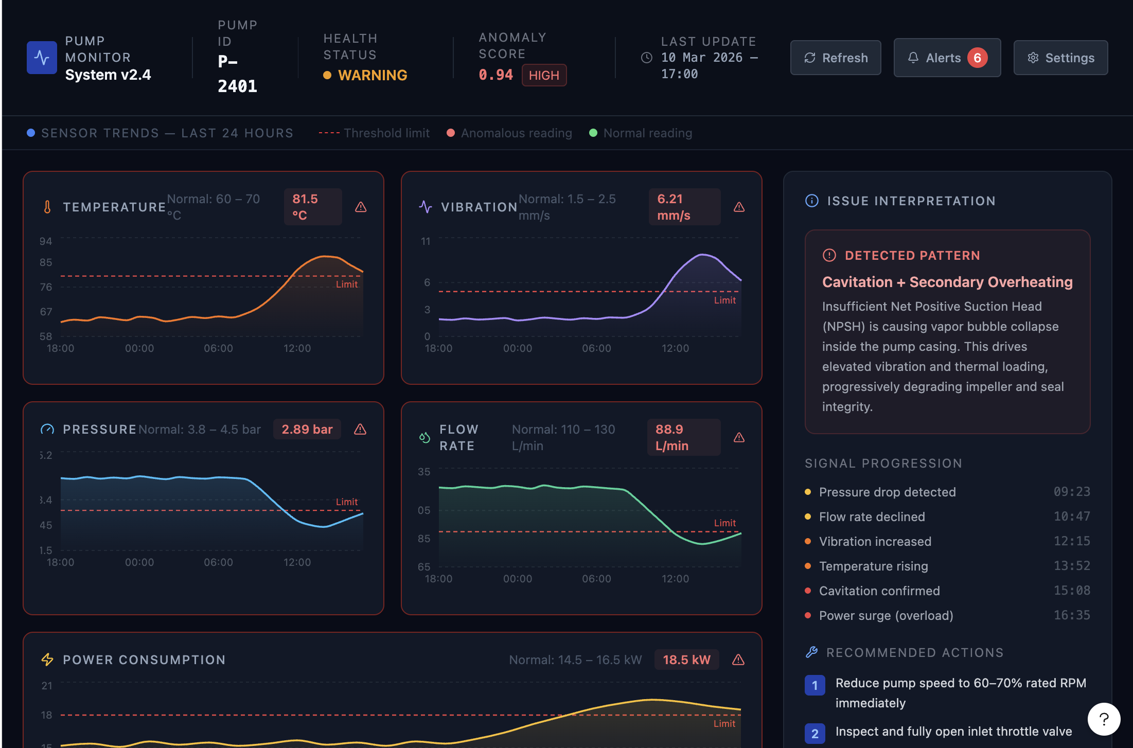
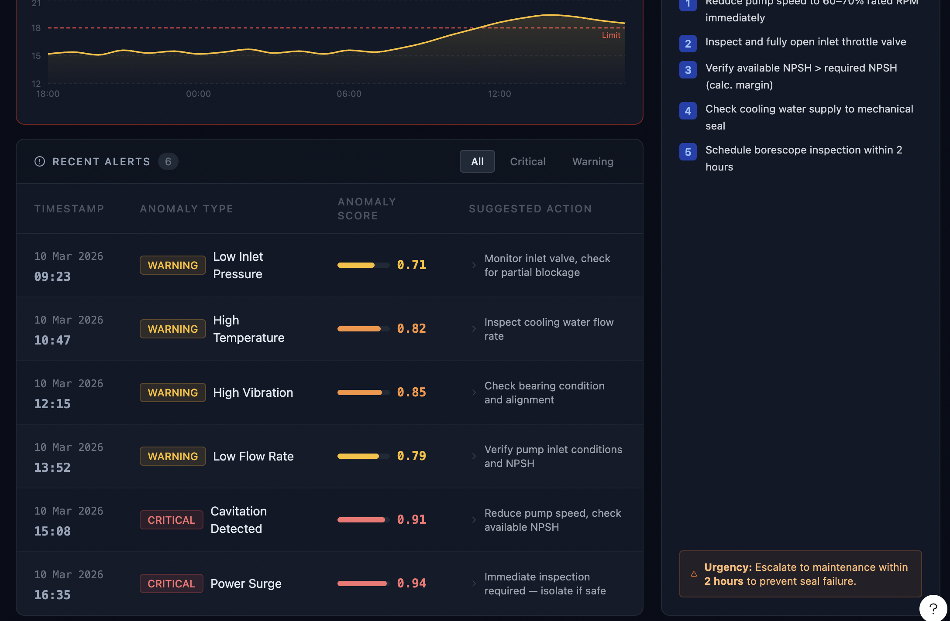

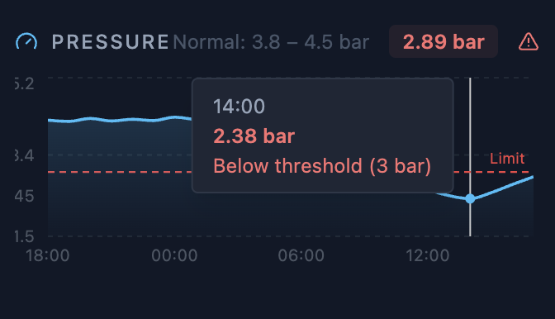

Agile Development Planning
Skeleton layout
↓
Load dataset
↓
Trend charts
↓
Anomaly score display
↓
Issue interpretation logic
↓
Alert history table

Step 1: the dashboard skeleton
This version will only build the layout, so you can confirm the structure matches your Figma design before we add data and model logic.

This file should be saved as: src/dashboard_app.py
Then run: streamlit run src/dashboard_app.py

Step 2 — Load Dataset + Sensor Charts
Your dashboard will show real time-series charts:

Temperature trend
Vibration trend
Pressure trend
Flow rate trend
Power trend

Each chart will display 5000 minutes of simulated pump behavior.

Step 3 — Connect the AI anomaly detector to the dashboard

Goal: Turn the dashboard from data viewer → AI monitoring system.

We will add:

Gaussian anomaly scoring
anomaly flag
health status logic
dynamic KPI values

Phase 6 — packaging
README, architecture diagram, screenshots, resume bullet, LinkedIn post.

Goal: make it portfolio-ready.

Deliverables

- README.md
- one architecture diagram
- 2–3 screenshots
- 2 resume bullets
- 1 LinkedIn post draft

Steps

- Write README with:

- customer problem
- architecture
- data pipeline
- AI logic
- business value

- Create one simple architecture diagram.
- Take screenshots of dashboard.
- Draft resume bullets.
- Draft one short LinkedIn post.

Time estimate

2 to 3 hours

Advice

If time is tight, finish README + screenshots first.
LinkedIn post can wait until after the build.

2-day execution timeline

Day 1 — core logic
Phase 1. Dataset simulation — 3 to 4 hours - morning
Phase 2. Baseline anomaly detector — 2 to 3 hours - afternoon
Phase 3. First round of feature engineering — 2 to 3 hours - evening

Day 2 — productization
Phase 4. Streamlit dashboard — 4 to 5 hours -morning + afternoon
Phase 5. Packaging — 2 to 3 hours - evening

Total: 13 to 18 hours

Risk control
The biggest risk is trying to do too much.
So here is the must-have / nice-to-have split.

Must-have

- one simulated dataset
- one Gaussian anomaly detector
- one improved feature set
- one working Streamlit dashboard
- one README

Nice-to-have

- multiple pumps
- live streaming simulation
- fancy UI
- advanced explanation engine
- Docker deployment

For this sprint, ignore the nice-to-have items.

